Use command $lscpu for stat about numa node , socket, core etc

NUMA - Non Uniform Memory Access

Introduction:-

Non Uniform Memory Access , which is a a system that is used in computer that contain multiple physical CPUs .

Lets us suppose a unicore CPU which is connected to RAM via ONE high speed BUS . this setup is a efficient setup .

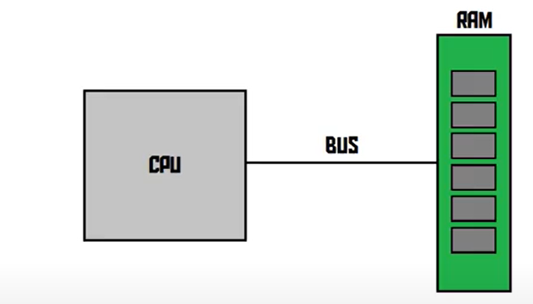

Now lets consider with computer with four CPU , now the question is how we can connect those CPU with the Single RAM .

Traditionally , in older times , we connect a high capacity RAM with a single BUS like

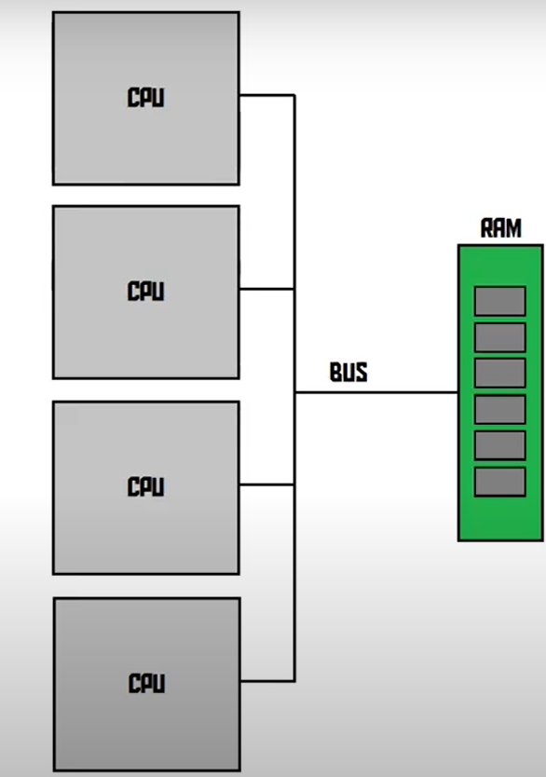
But this is quite a bad idea because this BUS is fast enought for one cpu but now here are four CPU . and this BUS is going to be completely saturated and that’s HORRIBLE

This problem even become bigger as we increase number of CPU.

NOW there comes NON UNIFORM MEMORY ACCESS

For NUMA we start with very basic case
So , in this case , every CPU has its own BUS and its own chunk of memory , which is blazing fast. AND there CPU and MEMORY pair are called as NUMA NODE .

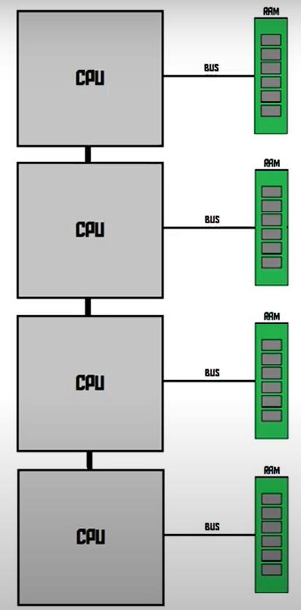

Why this is called NON-UNIFORM ?
Because here every CPU still able to access all of the memory but the speed is not the same , so accessing its own bit of memory is faster that accessing a bit of memory that is connected to some other CPU , this is why it’s called non-uniform.
It can access all the memory but not at same speed.

Suppose in average case CPU having there required memory in there chunk of block . and this make this system very efficient .

And far Superior that single BUS structure .

Usually a NUMA node is one CPU with one memory , but in certain condition like

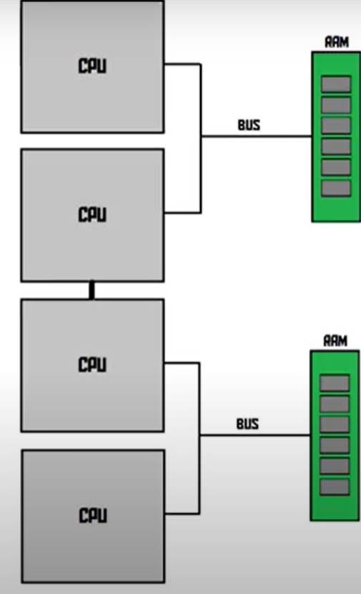

Here NUMA node is couple of CPU with one memory .

$numactl
This command use for “control NUMA policy for processor and shared memory”
$numactl -s =>to show numa policy setting of current process
$numactl --hardware => show inventory of available nodes (NUMA NODES) on the system

Historically, all memory on x86 systems is equally accessible by all CPUs. Known as Uniform Memory Access (UMA), access times are the same no matter which CPU performs the operation.

This behavior is no longer the case with recent x86 processors. In Non-Uniform Memory Access (NUMA), system memory is divided into zones (called nodes), which are allocated to particular CPUs or sockets. Access to memory that is local to a CPU is faster than memory connected to remote CPUs on that system.

NUMA MEMORY ALLOCATION POLICIES:-

The following policies define how memory is allocated from the nodes in a system:

- STRICT
Strict policy means that the allocation will fail if the memory cannot be allocated on the target node.
Specifying a NUMA nodeset list without defining a memory mode attribute defaults to strict mode.

2.INTERLEAVE
Memory pages are allocated across nodes specified by a nodeset, but are allocated in a round-robin fashion.

3.PREFERRED
Memory is allocated from a single preferred memory node. If sufficient memory is not available, memory can be allocated from other nodes.

Important:-

If memory is overcommitted in strict mode and the guest does not have sufficient swap space, the kernel will kill some guest processes to retrieve additional memory. Red Hat recommends using preferred allocation and specifying a single nodeset (for example, nodeset='0') to prevent this situation.

LIBVIRT NUMA TUNING:-

libvirt is an open-source API, daemon and management tool for managing platform virtualization. It can be used to manage KVM, Xen, VMware ESXi, QEMU and other virtualization technologies. These APIs are widely used in the orchestration layer of hypervisors in the development of a cloud-based solution.

Generally, optimal performance on NUMA systems is achieved by limiting guest size to the amount of resources on a single NUMA node. Avoid unnecessarily splitting resources across NUMA nodes.

Use the numastat tool to view per-NUMA-node memory statistics for processes and the operating system.

You can run numad to align the guests' CPUs and memory resources automatically. However, it is highly recommended to configure guest resource alignment using libvirt instead: .

Note:-

Running numastat with -c provides compact output; adding the -m option adds system-wide memory information on a per-node basis to the output. Refer to the numastat man page for more information.
For optimal performance results, memory pinning should be used in combination with pinning of vCPU threads as well as other hypervisor threads.

CORE :- A core is a physical subsection of a processing chip. It contains one interface to memory and peripherals. There can be multiple cores per chip or just one, although I think Intel no longer builds single-core CPUs.

Hyper-threading:-

Hyper-threading is the technology developed by intel . to in the performance of the CPU cores. It enables multiple threads to be run by each core to make the CPU run more efficiently .
With hyper-threading , the operating system will recognize each physical core as 2 virtual or logical cores .
Virtually doubles the amount of cores that’s on the CPU . so Dual core is recognise as Quad code by an operating system (but Virtually , ie operation seen by there lens).
So , Hyper-threading increases the amount of independent instruction in the pipelines .

Socket
Sockets represent the hardware. They are referred as number of processor sockets that your motherboard is having. Sockets are only capacity of motherboard. Socket can be empty. The real power is number of processors that are actually installed on motherboard.

Virtual Processor/VCPU
vCPU is time dependent entity. A virtual processor is more likely amount of processing time spent on the CPU. If we use technical terminology; Virtual processors are mapped to available logical processors in the physical computer and are scheduled by the Hypervisor software to allow you to have more virtual processors than you have logical processors. People may have misconception that 1 vCPU equals to 1 core. But there is no one to one relationship between vCPU and core in any virtualization software.

NUMA vCPU Pinning:-

vCPU pinning provides similar advantages to task pinning on bare metal systems.
Since vCPUs run as user-space tasks on the host operating system, pinning increases cache efficiency. One example of this is an environment where all vCPU threads are running on the same physical socket, therefore sharing a L3 cache domain.

Combining vCPU pinning with numatune can avoid NUMA misses. The performance impacts of NUMA misses are significant, generally starting at a 10% performance hit or higher. vCPU pinning and numatune should be configured together.

If the virtual machine is performing storage or network I/O tasks, it can be beneficial to pin all vCPUs and memory to the same physical socket that is physically connected to the I/O adapter.

Note

The lstopo tool can be used to visualize NUMA topology. It can also help verify that vCPUs are binding to cores on the same physical socket.

CORE:-

Cores are discrete element and therefore represent a very important look at our computers.
By looking at cores we can see how many independent parallel action can be taken by the processor at one time . This is very important for understanding the scaling and capacity ability of our computers . A computer can only truly parallelize to the extend of its “core ” capacity.

Cores are the number of processors within your physical cpu chipset .

SOCKET:-
Each socket is capable of holding one physical processor . A CPU socket or CPU slot is a

